

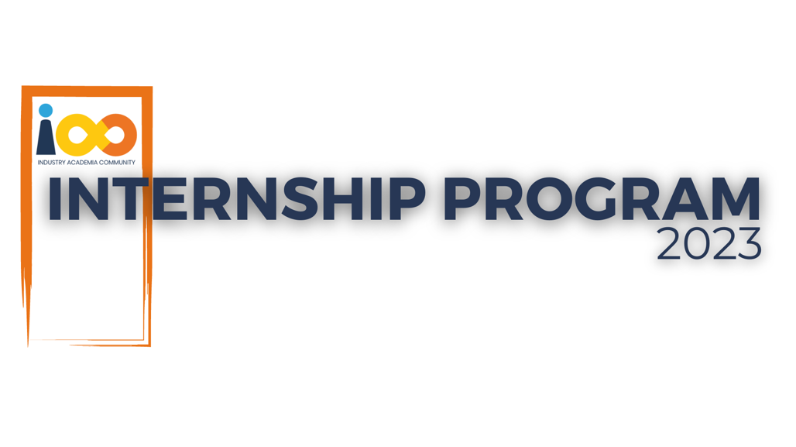

PROJECT REPORT

MACHINE LEARNING  
  
STUDENT GRADUATION AND PLACEMENT FORECASTING

|  |  |  |  |
| --- | --- | --- | --- |
| **Created By:** | RAMYADEEPA PALPANDI | **Approved By:** | Harshada Topale |
| **Created On:** | 20-09-2023 | **Approved On:** | 30-09-2023 |

Page left blank intentionally

**INDEX**

**1** **PROJECT DETAILS** 2

**2** **SUMMARY** 2

**3** **INTRODUCTION** 2

3.1 Background 2

3.2 Stakeholders 2

3.3 Objectives 2

**4** **METHODOLOGY** 2

4.1 Considerations & Assumption 3

4.2 Approach 3

4.3 Activities 3

**5** **TARGETTED V/S ACHIEVED OUTPUT** 3

**6** **CONCLUSION** 3

**General Instructions for using the Live Project Report Template**

* This template and the subsequent document created using this template is a confidential document and is the intellectual property of Cloud Counselage Pvt. Ltd. Circulating it outside of the organisation without the consent of Cloud Counselage Pvt. Ltd. is the breach of company policies and will lead to legal actions
* This template is a guideline document to communicate the implementation of design ideas and the results of the work to the stakeholders.
* The **text between inequality (< >) is to be replaced** by relevant text
* Please **remove the yellow highlight on the Text** between the inequality (< >). This is done to help you notice the text to be changed/replaced
* The text in *italics* highlighted in grey is just for reference and should be removed after adding the relevant text

# **PROJECT DETAILS**

|  |  |  |  |
| --- | --- | --- | --- |
| **Project Name** | Student Graduation and Placement Forecasting | | |
| **Project Sponsor** | Tushar Topale | | |
| **Project Manager** | Harshada Topale | | |
| **Start Date** | 07-08-2023 | **Completion Date** | 31-09-2023 |

# **SUMMARY**

This project aimed to develop a placement status prediction model using machine learning techniques and create a Python function to predict the graduation status of students based on academic data. The project addresses the need for automated student placement prediction and provides a valuable tool for educational institutions. The long-term benefits include improved placement success rates and better academic planning.

# **INTRODUCTION**

## Background

The project responds to the need for accurate placement prediction and efficient academic planning in educational institutions, driven by discussions during requirement elicitation meetings.

## Stakeholders

Stakeholders include educational institutions, students, and recruiters.

## Objectives

The objectives outlined in the Project Charter, such as building a placement prediction model and creating a graduation status prediction function, have been successfully achieved.

# **METHODOLOGY**

## Considerations & Assumption

Assumptions were made regarding data quality and availability. Constraints include limited data for certain features.

## Approach

A structured machine learning approach was adopted to build the placement prediction model. A Python function was created to predict graduation status based on academic data.

## Activities

Key activities included data preprocessing, feature engineering, model development, and testing.

# **TARGETTED V/S ACHIEVED OUTPUT**

The targeted output was a placement prediction model with a 66% accuracy rate, which was achieved. Also, the function is implemented to predict the graduation year of the students. The accuracy can be improved with a greater number of instances in the training dataset.

# **CONCLUSION**

The project's outcomes benefit educational institutions by enhancing placement prediction accuracy and aiding academic planning. Future scope includes expanding the model's capabilities and integrating it with student advising systems.